**Enhancing Customer Outreach By Using Social Media Network**

1N Jaswanth Reddy, 1N.V. Nithish Kumar, 1S. Farhan ,1M Upendra,

2Dr. Aarif Ahamed S

1UG Student Dept. Of CSE, 2Assistant Professor Senior Scale School of Computer Science and Engineering  
1,2Presidency University, Bengaluru-560064

1thorjaswanth970@gmail.com, 1nithishnagineni4@gmail.com, 1farhansodanapalli@gmail.com

1mekalaupendrareddy@gmail.com, 2aarif.ahamed@presidencyuniversity.in

**Abstract:**

The project "Scraping Flipkart, Amazon, Ajio and Myntra for E-Commerce Price Comparison" aims to build a comprehensive price comparison tool that aggregates product data from prominent e-commerce websites. Using some web scraping techniques, system collects the latest product availability, specs and prices from Flipkart, Amazon, Croma. With its easy-to-use system, this tool helps user to compare prices on multiple platforms, allowing them to make informed purchasing.

E-commerce has revolutionized consumer behaviour, offering an abundance of options. However, finding the best deals remains a tedious process, marked by challenges such as time consumption, missed opportunities, and information overload. This research explores a proposed solution: a unified app that integrates price comparison, coupon discovery, and price alerts for platforms like Amazon, Flipkart, Myntra, and Ajio. The study analyses the market need, technological feasibility, consumer behaviour, and competitive landscape to establish the app's potential as a comprehensive solution to modern shopping pain points.

Motivation: This is an invited review paper, which analyses the literature in the area of consumer decision making applied to online purchases, to identify the factors that significantly influence such purchases and further studies that can be targeted to provide a better understanding of consumer choice. This study provides insight into the complex interplay of the various forces that shape consumer value in the digital economy, conducting a preliminary investigation of the circumstances.

**Keywords:** Price Comparison, E-Commerce, Web Scraping, Web Crawling, User Interface, Price Alert, Trust, Perceived Risk, Social Influence.

**1.INTRODUCTION:**

In E-commerce has become a major force in today's digital landscape, transforming the way customers engage with products and shop. Customers now have unparalleled access to a wide range of products and services thanks to the growth of online shopping platforms, which also enable them to buy products from the comfort of their homes. But there are drawbacks to this ease as well, chief among them being the deluge of possibilities and the problem of finding the best deals on the things one wants. Effective price comparison tools are becoming more and more necessary as people look for value for their money. Titled "Scraping Flipkart, Amazon, and Croma for E-Commerce Price Comparison," satisfies this demand by creating a reliable system that gathers and contrasts product prices from Flipkart, Amazon, and Croma—the three most well-known e-commerce sites in India.

The increasing use of smartphones, better internet access, and shifting consumer habits are just a few of the reasons contributing to the growth of e-commerce. Due to the convenience of online shopping, which enables customers to browse and buy things whenever and wherever they choose, consumers are more likely to shop online these days. However, buyers frequently have a dilemma when deciding where to purchase a product due to the abundance of e-commerce websites available. It can be difficult for customers to get the best bargain because different platforms may offer different discounts, prices, and delivery choices. This is where price comparison websites come into play. They are useful resources that make buying easier by giving customers a single location to compare costs from several businesses.

Websites that compare prices have grown in popularity because they enable customers to make well-informed judgments about what to buy. These websites let consumers to view product prices side by side, assisting them in selecting the most economical solutions by combining data from multiple e-commerce platforms. Furthermore, a lot of price comparison websites provide services like price notifications, which alert consumers when a product's price falls to a predetermined point. This feature not only makes shopping more enjoyable, but it also motivates customers to make more deliberate purchases, which eventually results in cost savings. The suggested solution uses web scraping methods to get real-time data from Croma, Amazon, and Flipkart. Web scraping is the process of automatically extracting data from websites in order to efficiently obtain product details such as availability, prices, and descriptions. The system searches through the many e-commerce platforms using web crawlers to retrieve pertinent data, which is subsequently processed and presented on an intuitive interface. By guaranteeing that customers have access to the most recent data, this strategy helps them to make timely decisions based on the state of the market.

This the initiative's emphasis on the three main e-commerce sites, Flipkart, Amazon, Ajio and Myntra is one of its main advantages. With distinct advantages and features, every one of these platforms targets various market niches. For example, Amazon is renowned for its wide selection and customer-focused practices, while Flipkart is known for its wide assortment of products and competitive pricing. On the other hand, Croma offers customers a dependable source for tech-related products because of its expertise in electronics and appliances. The suggested method provides a thorough picture of the market by combining data from all three platforms, enabling customers to compare costs for a wide range of goods.

**2.LITERATURE SURVEY:**

* Shaikh, A., Khan, R., Panokher, K., Ranjan 2023, Price comparison websites are aimed to assist consumers in comparing the prices of goods and services from multiple sources, allowing them to make more educated decisions and save money when shopping online. Given the hectic lifestyles of city dwellers, many customers prefer to shop online for convenience and time savings. Consumers can save time by comparing costs for the same goods on price comparison websites rather than going from store to store. Instead, users can quickly check and compare pricing from numerous providers using a single platform. This project, dubbed "Price Comparison Website Using Web Scraping," seeks to provide a platform for consumers to locate the greatest bargains on products.
* Dharmik, H., Padmane, P., Dhoke, K. 2022, With the rapid rise of e-commerce, many online shopping platforms, like as Amazon, Flipkart, and Croma, now offer a wide range of products to consumers. However, the variety of websites might result in a large time investment for individuals looking for high-quality products at the lowest possible prices. Price comparison tools simplify the process by comparing products from numerous vendors, allowing customers to locate the best bargains and save money. Given the hectic schedules of urban customers, many prefer the convenience of internet shopping because it saves time and effort. A price comparison system reduces the need for customers to visit several offline establishments to check costs. Instead, consumers can see pricing comparisons and promotions on a single platform, making it easy to pick where to buy.
* LR Julian, F Natalia - 2015, The primary goal of employing web scraping for computer parts and assembly price comparison is to simplify the process of locating and comparing prices for distinct computer components from multiple online sellers. This approach uses web scraping techniques to combine real-time data from numerous e-commerce platforms and electronics retailers, allowing customers to quickly identify the best bargains on computer parts including CPUs, GPUs, motherboards, and other peripherals. The purpose is to give a complete and up-to-date comparison of costs and availability for computer components, allowing customers to make informed purchasing decisions while staying within their budget. This technology reduces the need for manual price checking and allows users to easily access and analyze pricing information, track price trends, and make cost-effective building decisions.
* Shridevi Swami , Pujashree Vidap 2013, The primary goal of creating a web scraping framework that combines tag and value similarity is to improve the accuracy and flexibility of data extraction from different and rapidly changing online sites. Traditional online scraping methods sometimes struggle with varied HTML structures and content formats on multiple websites, making it difficult to retrieve important information consistently. This system seeks to successfully handle these challenges by combining tag similarity (matching HTML tags and related characteristics) and value similarity (comparing the text within these tags). The framework aims to improve data extraction by enabling intelligent identification and extraction of desired information, regardless of changes in website layouts or structures. This approach offers a more versatile system capable of handling various types of web pages.
* Shalini, A., and Ambikapathy, R 2022, The project named "E-Commerce Analysis and Product Price Comparison Using Web Mining" aims to use web mining techniques to evaluate and compare product pricing across multiple e-commerce platforms. The study's goal is to create an effective solution for customers and businesses by utilizing innovative data extraction and analysis technologies to collect real-time pricing information from numerous internet shops. This research aims to help consumers make informed shopping decisions by providing a complete price comparison tool that shows the greatest offers and lowest prices accessible online. Additionally, the study intends to investigate market trends and pricing patterns in order to better understand the factors that influence price changes, such as promotional activities and seasonal trends.
* O. S. Al-Mushayt, W. Gharibi and N. Armi 2022, The primary goal of the study titled "An E-Commerce Control Unit for Addressing Online Transactions in Developing Countries: Saudi Arabia—Case Study" is to create and implement a control unit to improve the management and security of online transactions in developing countries, with a particular emphasis on Saudi Arabia. The purpose of this study is to solve the obstacles that e-commerce systems in developing countries confront, such as transaction security, fraud prevention, and regulatory compliance. The project aims to create a comprehensive control unit that combines sophisticated technology and best practices to properly monitor, manage, and safeguard online transactions. By tackling specific issues such as data privacy, payment fraud, and regulatory compliance, the study intends to increase the reliability and trustworthiness of Saudi e-commerce platforms.

**3.METHODOLOGY:**

* To effectively gather, handle, and display product data from multiple e-commerce platforms, the project "Scraping Flipkart, Amazon, Ajio and Myntra for E-Commerce Price Comparison" employs a methodology that encompasses multiple essential procedures.

**Benefits:**

* **Time Saving:** Users can compare prices across multiple platforms like Amazon, Flipkart, Myntra, and Ajio in one app, eliminating the need to browse each site individually.
* **Cost-Efficiency**: By discovering the best deals and lowest prices, users save money on their purchases without missing out on discounts or offers.
* **Convenience:** A centralized platform for price comparison and product discovery simplifies the shopping experience
* **WideSelection:**Access to multiple e-commerce platforms ensures a broader range of products and styles to suit every need.
* **Transparency:**Provides a clear, unbiased comparison, helping users trust they are getting the best deal.

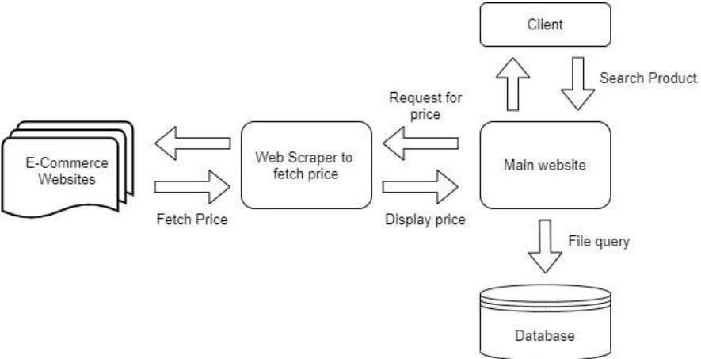

“Fig 1 System Architecture”

**4.IMPLEMENTATION**

**Implementation of the Price Feature :**

This stage sees the implementation of the price alert feature, which lets customers configure notifications for particular products. Users are able to specify a target price, and the system will track the price of the product on all e-commerce websites. The user can make timely purchasing decisions by receiving an alert when the price reduces to the designated level. This feature gives customers a proactive tool to assist them get the greatest deals, which increases the application's overall value.

**Implementation:**

After testing is finished and any required modifications are done, the application is launched on a hosting platform of choice. During this phase, the server environment must be configured, the program must be made user-accessible, and performance enhanced. When a tool is deployed, it moves from development to a live environment and users can begin using it to improve their online purchasing experience.

**5.EXPERIMENTAL RESULTS:**

"Fig1:Login Page"

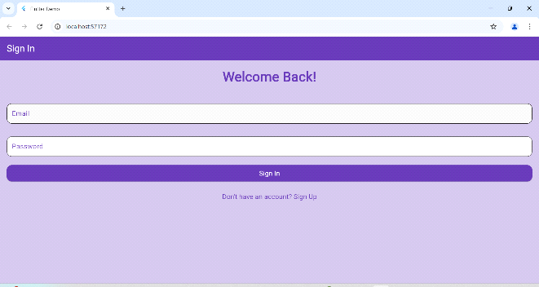

“Fig 2 Home Page”

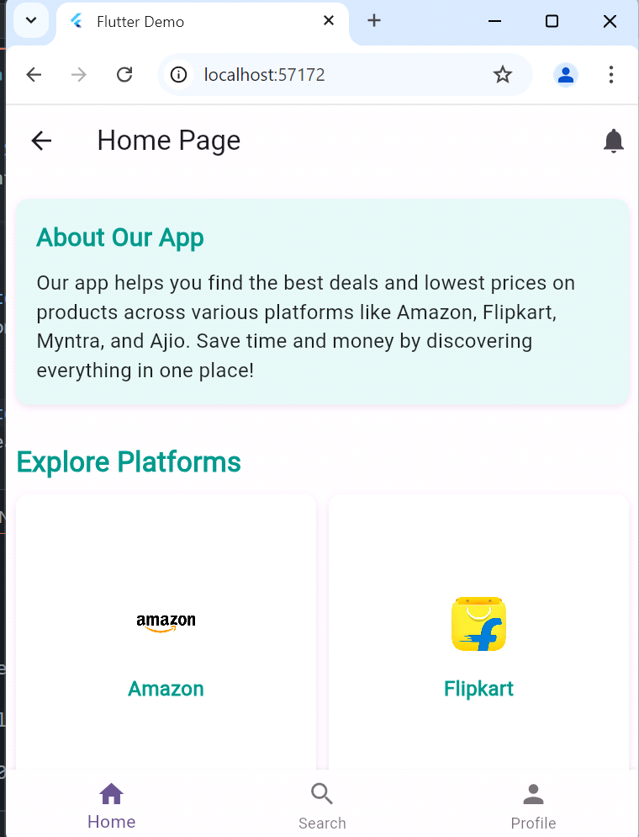

“Fig 3Search Screen”

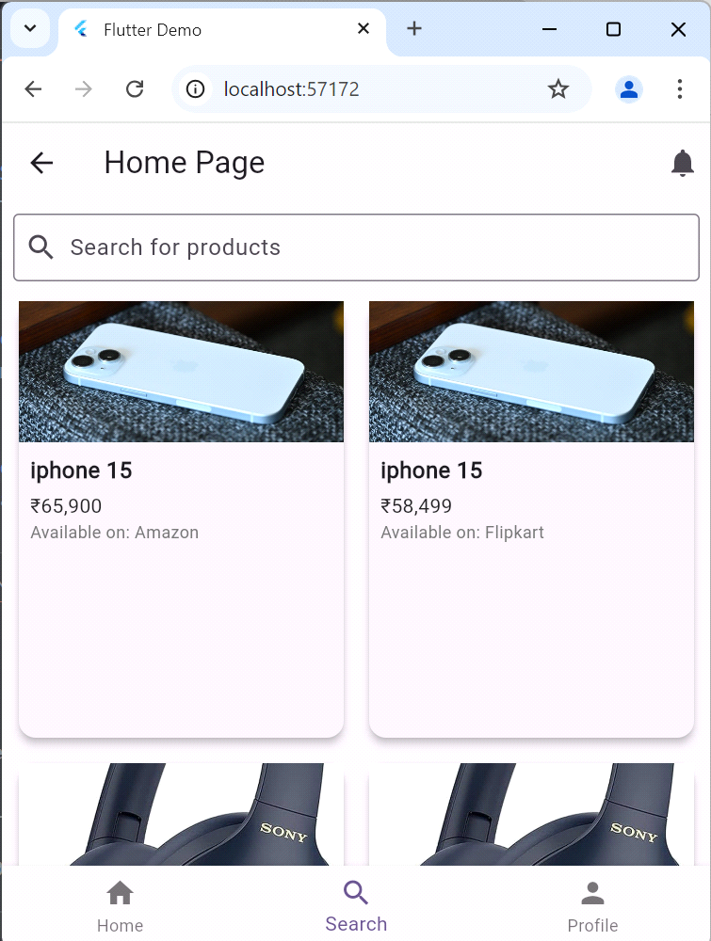

“Fig 4 Notifications”

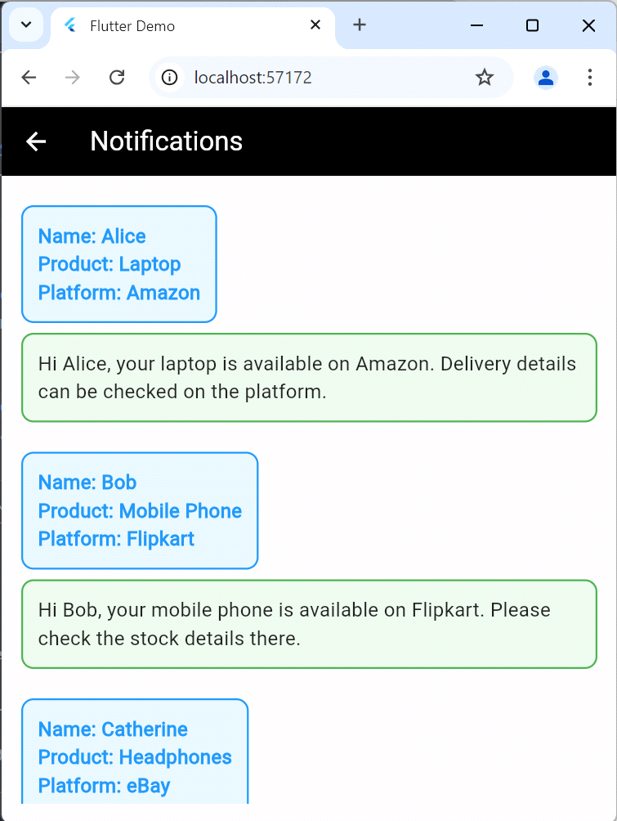

“Fig 5 Profile Page”

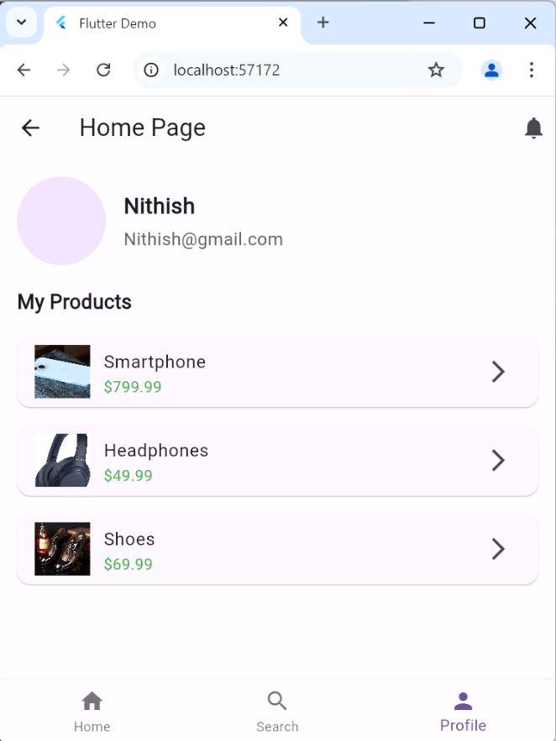

“Fig 6 Submit Form”

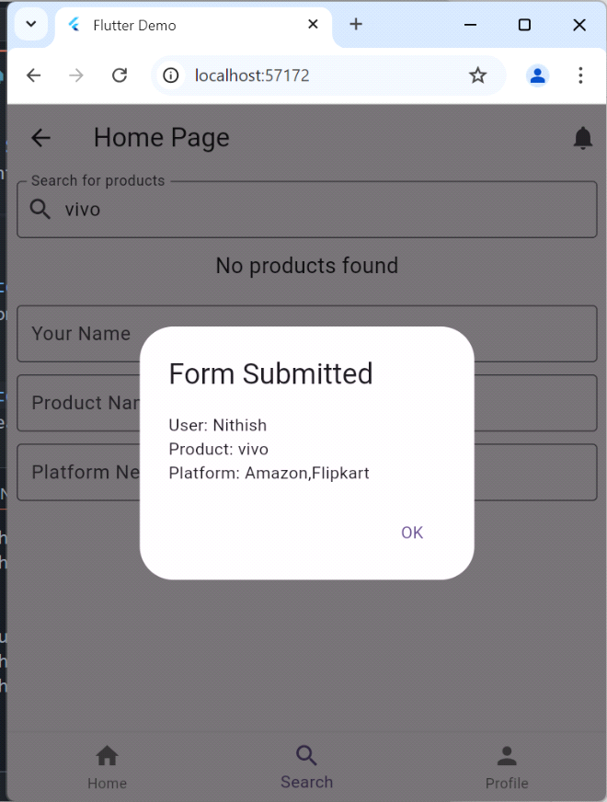

**6.RESULT :**

The introduction of the price comparison website has yielded noteworthy outcomes, as it effectively compiles and presents product prices from many e-commerce platforms, such as Flipkart, Amazon, and Croma, on a unified interface. On this user-friendly website, customers can easily search for products and compare prices to discover the best deals without having to visit each website separately. Web scraping allows for the efficient extraction of relevant product information, guaranteeing users receive up-to-date and accurate data. The shopping experience is further enhanced with a price alert feature that tells customers when a product's price drops to a desired level. Overall, this approach saves users a great deal of time and effort and is a helpful resource for internet shoppers looking to make well-informed choices.

7**.CONCLUSION:**

In conclusion, the price comparison website effectively tackles the difficulties encountered by shoppers when traversing the extensive range of e-commerce platforms. The system gathers product data from various sources by using web scraping and crawling techniques. This makes it simple for customers to compare prices and locate the greatest offers in one handy place. When paired with features like price alerts, the user-friendly interface improves the whole shopping experience by empowering customers to make well-informed decisions while saving time and money. This project is an example of how technology may enhance the efficiency of online shopping while also making the purchasing experience easier for users. These kinds of technologies will be essential in assisting customers in sorting through their alternatives and streamlining their purchasing techniques as e-commerce expands.

**8.REFERENCES:**

**[1]** Shaikh, A., Khan, R., Panokher, K., Ranjan, M. K., & Sonaje, V. (2023). E-commerce Price Comparison

Website using Web Scraping. International Journal of Innovative Research in Engineering &

Multidisciplinary Physical Sciences, 11(3). [https://doi.org/10.37082/ijirmps.v11.i3.230223 HYPERLINK "https://doi.org/10.37082/ijirmps.v11.i3.230223"](https://doi.org/10.37082/ijirmps.v11.i3.230223%20HYPERLINK%20%22https://doi.org/10.37082/ijirmps.v11.i3.230223%22)

**[2]** Dharmik, H., Padmane, P., Dhoke, K., Chambhare, S., & Kohad, D. (2022). A Review on E-commerce Price Evaluation System. International Journal for Research in Applied Science and Engineering Technology, 10(5),4890–4893. [https://doi.org/10.22214/ijraset.2022.43321 HYPERLINK "https://doi.org/10.22214/ijraset.2022.43321"](https://doi.org/10.22214/ijraset.2022.43321%20HYPERLINK%20%22https://doi.org/10.22214/ijraset.2022.43321%22)

**[3]**The use of web scraping in computer parts and assembly price comparison LR Julian, F Natalia - 2015 3rd International Conference on …, 2015 - ieeexplore.ieee.org

**[4]** Shridevi Swami , Pujashree Vidap ,” Web Scraping Framework based on Combining Tag and Value Similarity” Proceedings of the IJCSI International Journal of Computer Science Issues, Vol. 10, Issue 6, No 2, November 2013.

**[5]** Shalini, A., and Ambikapathy, R. "E-Commerce Analysis and Product Price Comparison Using Web Mining." International Journal of Research Publication and Reviews, vol. 3, no. 6, June 2022, pp. 36203623. ISSN: 2582-7421.

**[6]** O. S. Al-Mushayt, W. Gharibi and N. Armi, "An E-Commerce Control Unit for Addressing Online Transactions in Developing Countries: Saudi Arabia—Case Study," in IEEE Access, vol. 10, pp. 6428364291, 2022, doi: 10.1109/ACCESS.2022.3180329.